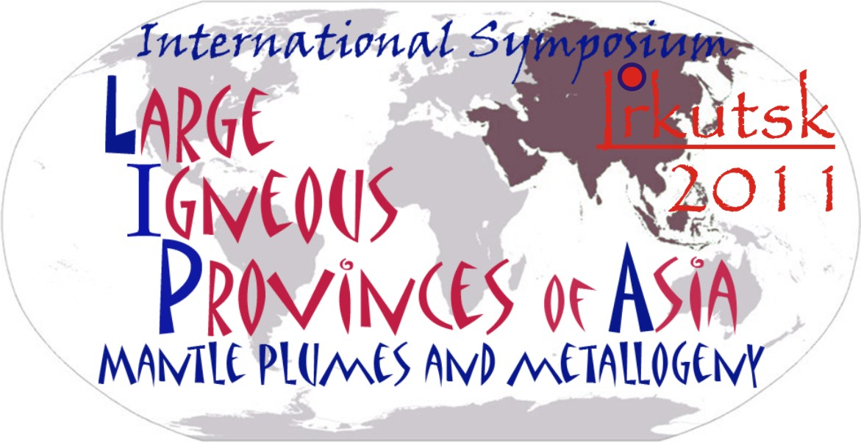

International Symposium

LARGE IGNEOUS PROVINCES OF ASIA, MANTLE PLUMES AND METALLOGENY

Organized by

Institute of the Earth’s crust, Siberian Branch

of Russian Academy of Sciences (IEC SB RAS)

20 - 28 August 2011, Irkutsk, Russia

First circular

The conference is focused on the following topics:

1. An origin, age, and duration of the activity of large igneous provinces (LIPs) of Asia;
2. Modeling of processes responsible for the creation and development of mantle plumes, mantle-crust interaction and plume-related ore-magmatic systems;
3. Tectonic, petrological and geochemical aspects controlling the location and activity of local magmatic complexes within large igneous provinces of Asia;
4. Granite LIPs and their role in global geodynamics;
5. Role of LIPs in world-wide tectonic correlations;
6. Metallogenic specialization of LIPs and the role of mantle plumes in the formation of unique mineral deposits of Asia;
7. Possible links between the largest magmatic events, natural disasters and global climate changes

Program of the Conference:
20 August: Accommodation in Irkutsk, Registration, Ice Breaker Party
21 August: Opening ceremony, thematic sessions
22 August: Thematic sessions, cultural event.
23 August: Thematic sessions, general discussions, banquet.
24 – 28 August: field trip «LIPs of the Baikal area»

Field Trip

20 - 24 August field trip «LIP of the Baikal area»
The itinerary covers a total of 1500 km.
Preliminary cost 480 EUR. 20 participants as maximum.
Field trip leaders: D.P. Gladkochub, T.V. Donskaya, A.A. Tsigankov

Organizing Committee
Chairmen:
Eugene Sklyarov – Corresponding member of RAS, Director of the Institute of Earth’s crust SB RAS, Irkutsk, Russia

Mikhail Kuzmin - Academician, Institute of Geochemisty SB RAS, Irkutsk, Russia

Franco Pirajno - Professor, Geological Survey of Western Australia, School of Earth and Geographical Sciences, University of Western Australia, Australia

Bor-ming Jahn – Professor, Academia Sinica, Institute of Earth Sciences, Taiwan

Vice-Chairmen:
Nikolai Dobretsov - Academician, Institute of Geology and Mineralogy SB RAS, Novosibirsk, Russia
Zheng-Xiang Li - Professor, Department of Applied Geology, Curtin University of Technology, Perth, Australia
Dmitry Gladkochub – Dr.Sci, Deputy Director of Institute of the Earth’s crust SB RAS, Irkutsk, Russia
Richard Ernst - PhD, “Ernst Geosciences”, formerly at the Geological Survey of Canada, Canada
Alexander Borisenko – Dr.Sci, Deputy Director of Institute of Geology and Mineralogy of SB RAS, Novosibirsk, Russia
International Scientific Committee:
Alexander. Khanchuk - Academician, Russian Academy of Sciences, Director of Far East Geological Institute Far East branch of RAS, Vladivostok
Nikolai Sobolev - Academician, Russian Academy of Sciences, Institute of Geology and Mineralogy SB RAS, Novosibirsk
Ivan Gordienko - Corresponding member of RAS, Buryatian Scientific Center of SB RAS, Ulan-Ude
Gleb Polyakov - Corresponding member of RAS, Institute of Geology and Mineralogy SB RAS, Novosibirsk
Vladimir Shatskiy - Corresponding member of RAS, Deputy Director of Institute of Geology and Mineralogy of SB RAS, Novosibirsk
Nikolay Pokhilenko - Corresponding member of RAS, Director of Institute of Geology and Mineralogy of SB RAS, Novosibirsk
Nikolay Goryachev - Corresponding member of RAS, Director of NEIRSI FEB RAS, Magadan
Vladimir Yarmolyuk - Corresponding member of RAS, Deputy Director of Institute of Geology of ore deposits, Petrology, Mineralogy and Geochemistry RAS, Moscow
Andrey Izokh - Professor, Institute of Geology and Mineralogy of SB RAS, Novosibirsk
Alexander Vladimirov - Professor, Institute of Geology and Mineralogy of SB RAS, Novosibirsk
Reimar Seltmann - Professor, Head CERCAMS (Centre for Russian and Central Eurasian Mineral Studies), Natural History Museum, London, United Kingdom
Sergey Pisarevsky – PhD, School of Earth and Environment,
University of Western Australia, Australia
Jingwen Mao - Professor, Institute of Mineral Deposits, Chinese Academy of Geological Sciences, Beijing, China.
Onongin Tomurtogoo - Academician of Mongolian Academy of Sciences, Institute of Geology and Mineral Resources, Mongolian Academy of Sciences, Mongolia
Nigel Cook - Professor, IAGOD President, Natural History Museum (Geology), University of Oslo, Oslo, Norway
Tran Trong Hoa - Director of Institute of Geological Sciences, Vietnamese Academy of Sciences and Technology, Vietnam
Wang Tao – Professor, Institute of Geology, Chinese Academy of Geological Sciences, China

Executive Secretaries:
Dr. Sc. Dmitry Gladkochub (gladkochub@mail.ru)
PhD Tatiana Donskaya (Tatiana_Donskaya@mail.ru)

Conference publications will include:

1. Conference Program and Proceedings Volume containing the Extended Abstracts (in English)

2. Field Excursion Guidebook (in English)
3. Special issue of “Russian Geology and Geophysics”
4. Special issue of “Asian Journal of Earth’s sciences”

General Information

Conference Languages: The official language of the conference is English. All posters are to be prepared in English. We encourage the Russian participants to present their talks in English. Those participants who are not comfortable with this are kindly advised to arrange for interpretation through their bilingual colleagues (own preliminary agreement required) or to consider participation in a poster session.
Climate: The conference period is characterized by moderate (20-35 C) temperatures with moderate precipitation.

Travel: The airport Irkutsk (www.iktport.ru) is the center of passenger and cargo transport in Eastern Siberia. The airport offers direct connections with over 60 cities in Russia, CIS and abroad. The airport is linked to the city by public transport and taxis.

Please inform us about your arrival in advance and we will pick you up at the airport (cost is about 15 EUR)

The Organizing Committee recommends don’t use the services of private drivers.

Russian railways (http://www.eng.rzd.ru) Long-distance trains run from Europe to Irkutsk (via Moscow). There are also direct trains from Beijing, Ulan Bator, Ukraine, Kazakhstan and other places.

Visa: Most foreign participants will be required to obtain a visa to enter Russia, which may take you some time. Please check your visa requirements with the Consulate General of Russia in your home country. A formal letter of invitation is a likely prerequisite for visa application, and if this is the case, such a letter will be sent upon your request soon after you let us know.

Irkutsk is one of the oldest cities in Russian Siberia (established at 1661) and is large cultural, scientific and tourist center beyond the Urals. More information about Irkutsk can be found at www.irk.ru and http://en.wikipedia.org/wiki/Irkutsk

Accommodation: Rooms in Hotel “Akademicheskaya”are available at various rates and degrees of comfort within a 10 minute walking distance from the conference site in Academgorodok. Room prices are in range 60-180 Euros. Accommodation should be reserved through the Organizing Committee.

Insurance liability Participants should note that emergency medical costs are not covered by the registration fee.

Conference will be held at the Institute of the Earth’s crust SB RAS

Co-sponsors:
 | Siberian Branch of Russian Academy of Sciences
 | Russian Foundation for Basic Research (RFBR)
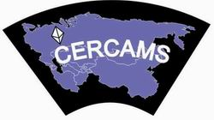 | Centre for Russian and Central Eurasian Mineral Studies (CERCAMS)
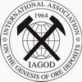 | International Association on the Genesis of Ore Deposits (IAGOD)
Key Dates
1 January 2011 – Start of registration
1 May 2011 - Registration deadline
1 May 2011 - Excursions registered deadline
1 May 2011 - Abstract deadline
All abstracts should be submitted in English (up to 2 pages, font Times New Roman 12, single space, all margins 2.5 cm, in MS Word format, figures should be sent in separate file)
by April 1, 2011.
Registration Fees
Registration fees of €150 for conference participants, €100 for accompanying persons, and €50 for students allow attendance at the sessions, ice-breaking party & banquet.
Final excursion fees and methods of payment will be indicated in the Second Circular (March 2011).

Registration
On-line registration is available at the conference website: http://lip-asia.com

If you are unable to register on-line, fill in the form and send it back to the Organizing Committee

REGISTRATION FORM
First Name__________________________________
Last Name_________________________________________
Title:_______________________________________________________________________________________________
Institution:_________________________________________
__________________________________________________Address:____________________________________________________________________________________________
Phone:______________________Fax:__________________
E-mail:____________________________________________
Provisional title of my talk/poster ____________________________________________________________________________________________________
Accompanying person(s)__________________________________________
__________________________________________________
I consider to participate in the field excursion_____________

Contacts:
Phone +7(3952)427117
Fax +7(3952)427000
Organizing Committee of Conference
“THE LARGE IGNEOUS PROVINCES OF ASIA,
MANTLE PLUMES AND METALLOGENY”

IEC SB RAS, 128, Lermontov St., Irkutsk, Russia, 664033

WEB: http://lip-asia.com
e-mails: Gladkochub@mail.ru
Tatiana_Donskaya@mail.ru

