 |  | 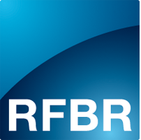 | 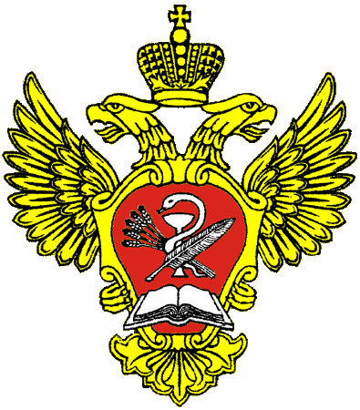
RUSSIAN ACADEMY OF SCIENCES, SIBERIAN BRANCH
INSTITUTE OF THE EARTH'S CRUST

DEBRIS FLOW ASSOCIATION

RUSSIAN FOUNDATION FOR BASIC RESEARCH

FEDERAL AGENCY FOR SCIENTIFIC ORGANIZATIONS
First Announcement
Dear colleagues!
On behalf of the Institute of the Earth’s Crust of Siberian Branch of the Russian Academy of Sciences and the Debris flow Association, the Organizing Committee would like to invite you to take part in the International Youth Science School "Debris flows: regional features of formation and methods of research", which will be held on August 1-10, 2018. Working Sessions will be held at the conference hall of Institute of the Earth's Crust (Irkutsk), field trips will take place in the Arshan village (Tunka Ridge) and on the Baikal shore.
The school is designed for young scientists, PhD students and students of geological and geomorphological study areas. The program of the school will include lectures by Russian and foreign scientists about the features of the debris flow formation in the different debris flow-prone regions, demonstration of field methods of research and equipment for the study of debris flows, and also poster presentations of participants. The purposes of the event: advanced training of specialists in the area of debris flow studying, an exchange of knowledge and experience in studying of debris flow, as well as building of long-term scientific contacts.
At the end of the School all the participants will be awarded certificates about participation from the School Organizing Committee and Debris Flow Association.
Field trips:
Within the framework of the school three field trips on the main debris flow-prone areas of Eastern Siberia will be offered:
1) Train trip along the Circum-Baikal railway;
2) Bus tour to the south-eastern shore of Baikal (foothills of Khamar-Daban Ridge);
3) Field trip to foothills of Tunka Ridge (Arshan village).
Preliminary program of the school:
Day 1: Meeting of participants. Accommodation in hotels of Irkutsk. City Tour. Welcome friendly dinner.
Day 2: Sessions in the conference hall of the Institute of the Earth's Crust (lectures, poster presentations, discussions).
Day 3: Excursion by train on Circum-Baikal Railway, sightseeing of historical protection structures and old debris flow fans.
Day 4: Departure to Arshan village. Lecture-excursion about the debris flow event in the vicinity of Arshan village on June 2014. Accommodation at the camp site.
Day 5: Field route to the debris flow basin in the Artem`eva creek channel (the approximate distance of the route is 10 km, elevation is 400 m).
Day 6: Field route to the debris flow origin zones in the hanging cirques of the Tunka Ridge (the approximate distance of the route is 11 km, elevation is 1000 m).
Day 7: Field route along the Kyngarga river (approximate distance of the route is 10 km, elevation is 300 m).
Day 8: Transfer to the town of Baikalsk. Excursion along the Baikal shore.
Day 9: Sightseeing of the old debris flow fans in the vicinity of the town of Baikalsk and debris flow protection structures. The final gala dinner.
Day 10: Return to Irkutsk, transfer to airport.
Organizational fee for participants of the school: $1080. Options for payment of the organizational fee: 1) bank transfer, 2) cash payment on arrival. The sum does not depend on the payment option. To request payment details of the organizational fee by bank transfer, please write to: kadetova@crust.irk.ru
The organizational fee includes: transfer from / to the airport; participation in school sessions; coffee-breaks; participant's package; excursion guide book, transfers according to the program; accommodation at the camp site in the Arshan village; accommodation at the hotel in Baikalsk; 3 meals a day in the Arshan village and in the town of Baikalsk; all excursions and field trips according to the program; two gala dinners; visa support, including forwarding documents.
Accommodation and meals in Irkutsk are not included in the organizational fee. However, at the request of the participants, the organizing committee can assist in booking hotels located near the Institute of the Earth's Crust.
Visa:
Organizing Committee will provide visa support for conference guests from other countries. In order to get the official invitation the participants are requested to complete all the items of the registration form and attach a scanned copy of the passport page with photo and personal information. Deadline for the submission is April 1, 2018. Be aware that the passport is to be valid for 6 months after the trip.
Language
The official School language is English.
Contact information
Institute of the Earth’s Crust of Siberian Branch of the Russian Academy of Sciences
Lermontov str. 128, 664033, Irkutsk
Co-chairs of the Organizing Committee:
Director of the Institute of the Earth`s crust Gladkochub Dmitry Petrovich
President of the Debris Flow Association Chernomorets Sergey Semenovich
Vice-chair of the Organizing Committee:
Head of the Laboratory of Engineering Geology and Geoecology Elena A. Kozyreva
Secretary of the Organizing Committee:
Alena V. Kadetova
Phone: +7-3952-42-5899
Fax: +7-3952-42-6900
E-mail: kadetova@crust.irk.ru (A. Kadetova)

International Youth Science School
"Debris flows: regional features of formation and methods of research"

REGISTRATION FORM

Last name____________________________________________________________________

First name___________________________________________________________________

Middle name____________________________________________________________

Birth date___________ Sex: □ Male □ Female

Title of presentation:________________________________
_____________________________________________________________________________

Position:
_______________________________________________________________________

Organization:________________________________________________________________
_____________________________________________________________________________

Phone: +_________________, E-mail: _________________________

Hotel booking_________________________________________________________

